**Assignment-11-May-2022:**

1. **What are the difference AWS storage services available in AWS?**

* S3 (Simple Storage Service)
* EBS (Elastic Block Storage)
* EFS (Elastic File Storage)
* Instance Storage

1. **Explain the difference between S3, EFS, EBS and Instance store**

Amazon S3 is a cloud storage service that can be accessed from anywhere. AWS EBS is only accessible in a single region, while multiple EFS instances can share files across multiple regions.

EBS and EFS both outperform Amazon S3 in terms of IOPS and latency.

With a single API call, EBS can be scaled up or down. You can use EBS for database backups and other low-latency interactive applications that need reliable, predictable performance because it is less expensive than EFS.

(OR)

**EFS’s**

EFS is a file storage system. File storage is the system you’ll likely be most familiar with, as it’s how files are stored in the hard drive on your computer. File storage is fast and accessible, but it doesn’t offer the increased potential for complex queries that object storage does (more on that in the S3 section).

### **EFS’s key benefits**

* **Adaptive throughput** – EFS’s performance can scale in-line with its storage, operating at a higher throughput for sudden, high-volume file dumps, reaching up to 500,000 IOPS or 10 GB per second
* **Totally elastic** – once you’ve spun up an EFS instance, you can add add files without worrying about provisioning or disturbing your application’s performance
* **Additional accessibility** – EFS can be mounted from different EC2 instances, but it can also cross the AWS region boundary via the use of VPC peering.

EFS may be used whenever you need a shared file storage option for multiple EC2 instances with automatic, high-performance scaling.

### **EBS’s key benefits**

* **Low-latency performance** – Up to 16,000 IOPS for General Purpose SSDs and up to 256,000 IOPS for the new Provisioned IOPS SSD
* **Easy data backup and restoration** – via snapshots that can be taken at hourly intervals, EBS ensures all your data is well protected
* **Highly available** – 99.8% – 99.9% for General Purpose SSDs and 99.999% for the Provisioned IOPS SSD
* **EBS encryption** – there’s no need to worry about key management, as EBS handles that for you.

### **When to use EBS?**

EBS’s use case is more easily understood than the other two. It must be paired with an EC2 instance. So when you need a high-performance storage service for a single instance, use EBS.

**S3**

S3 is an object storage service. Unlike file storage – in which all data is organised hierarchically in a top-down network of folders – data in S3 is contained on the same flat plane, with more comprehensive metadata (labels) to make it manageable.

### **S3 key benefits**

* **Running analytics** – because S3 can interface with other services like AWS Lake Formation and analytics tools, it can be used as a data lake, with other services running complex queries on its data to draw insights
* **Data archiving** – S3 is capable of archiving data, meaning simpler forms of your data can be stored at a lower cost than a ‘fuller’ version would
* **Highly available** – S3 boasts 99.99% + availability
* **Flexible** – S3 can be mounted on an application to act as a shared drive, making files shareable across multiple instances running the web application

### **When to use S3?**

S3 is good at storing long-term data due to its archiving system. Things like reports and records, which may go unused for years, can be stored on S3 at a lower cost than the other two storage services

**3. What are the different classes of S3 or category of s3.**

* S3 Standard (for frequently accessed data)
* S3 intelligent - Tiering (for automatic cost savings for data with unknown or changing access patterns, )
* S3 Standard - InfrequentAccess
* S3 One Zone - IA (for less frequently accessed data)
* S3 Glacier ( for rarely accessed long-term data that does not require immediate access)
* S3 Glacier Deep Archive (for long-term archive and digital preservation with retrieval in hours at the lowest cost storage in the cloud)

**4. How to host a static website in S3? (steps with screen shots)**

**1.open S3 and create one bicket by providing name .Region**

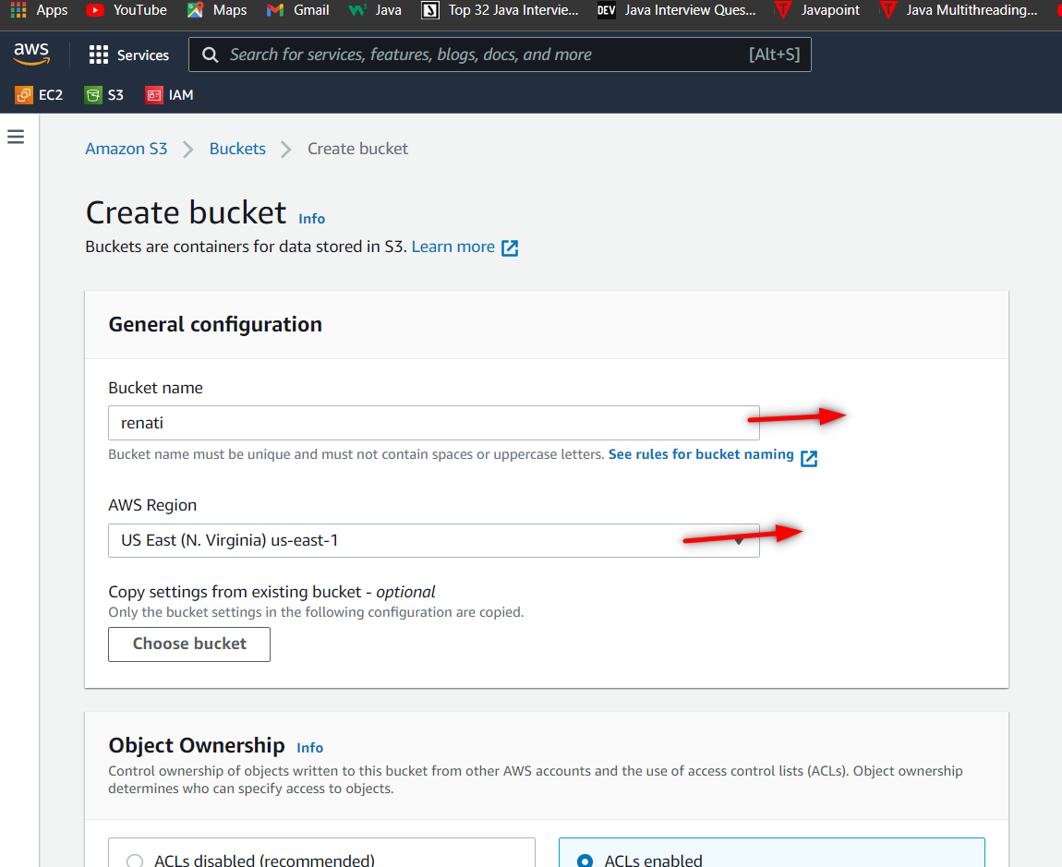

1. **Enable the ACLs and uncheck the Block all public access. And create bucket.**

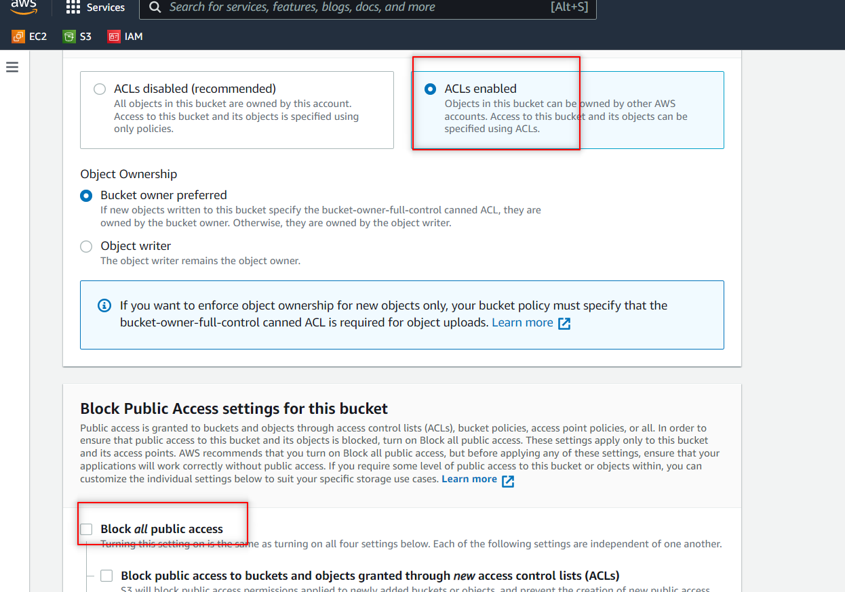

**3.Go to permissions and give permission to public access and sace changes.**

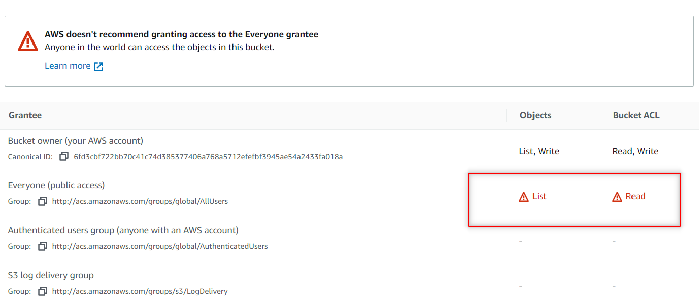

**4.Then upload the file/object which is html.**

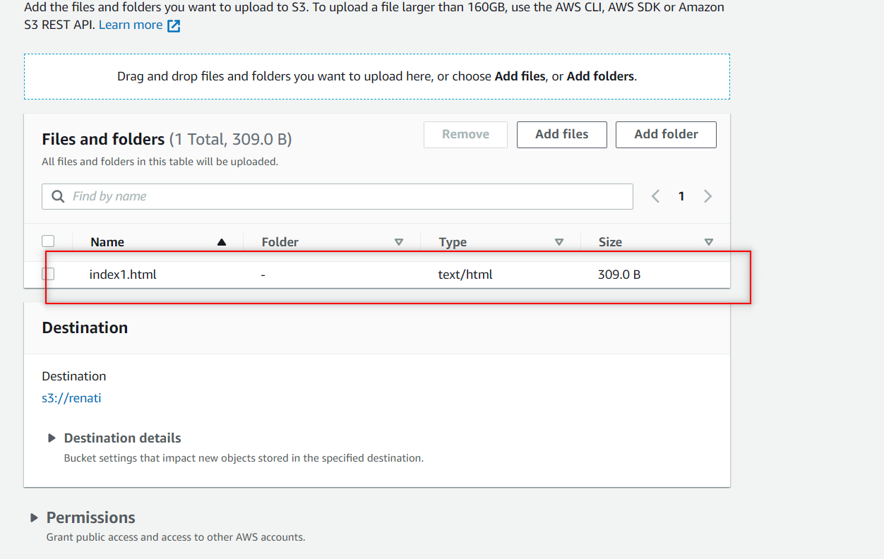

1. **Same as bucket level ,provide access at object level as well.**

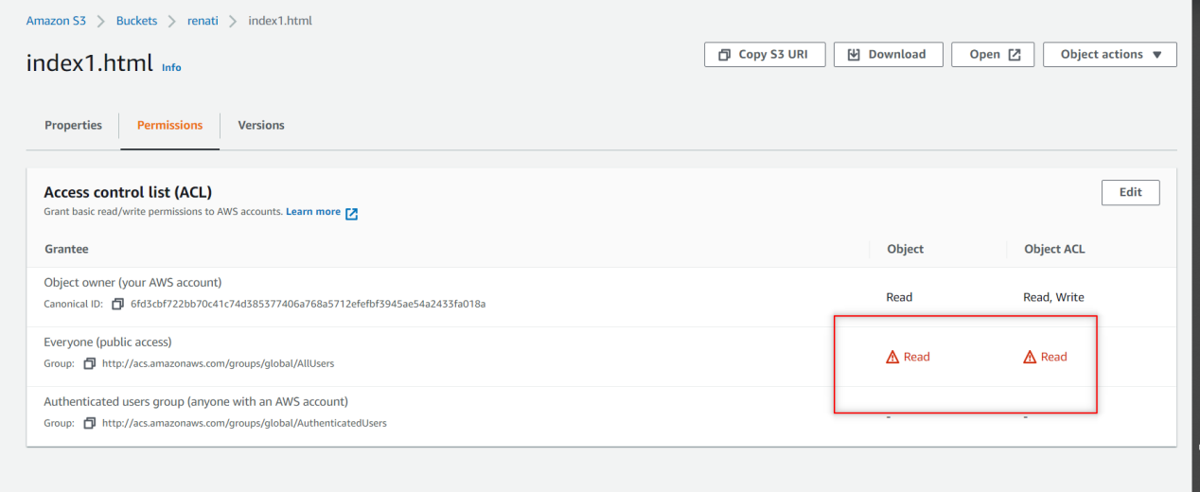

**6.Now go to your bucket and go to properties there u can see the static website hosting … click on edit button.**

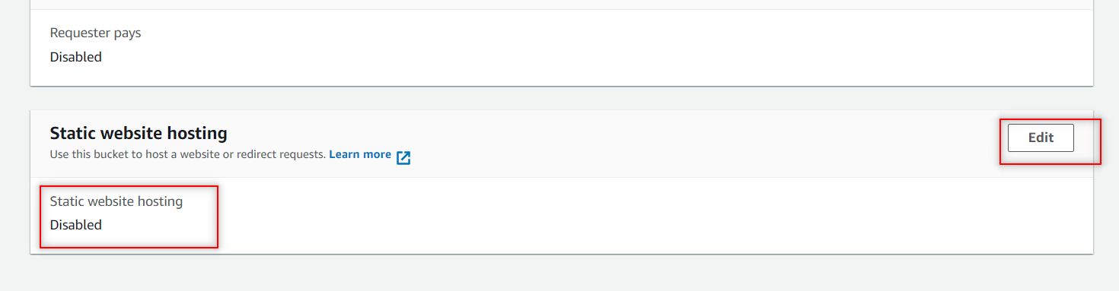

**Change to enable and provide the file name which u have uploaded.**

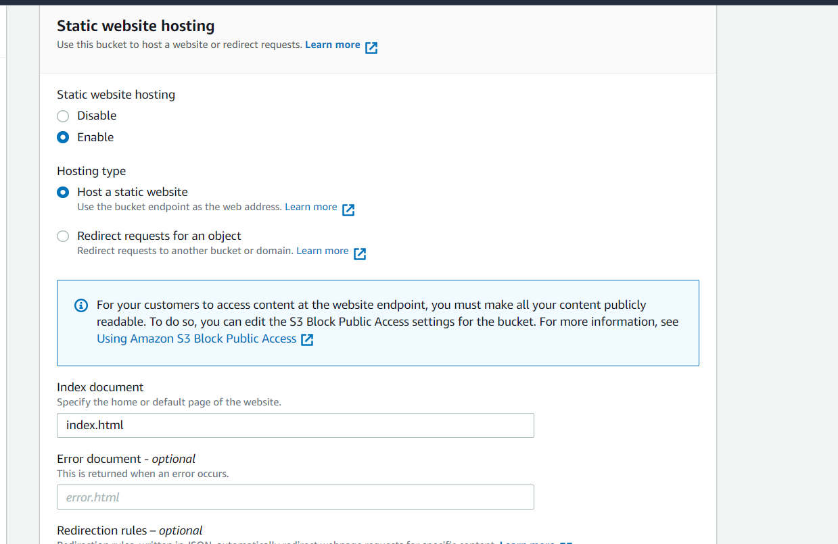

**Now copy the URL which u can see below and paste it in google.**

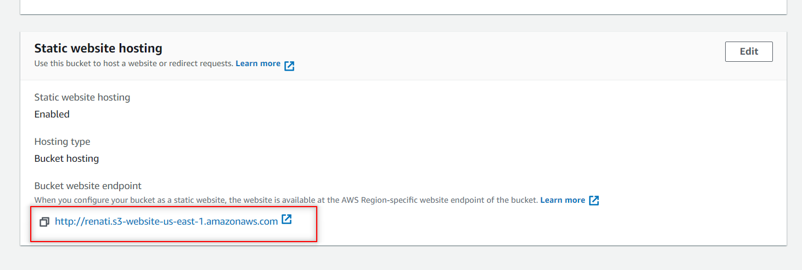

**After pasting the URL in google , the data can be seen**

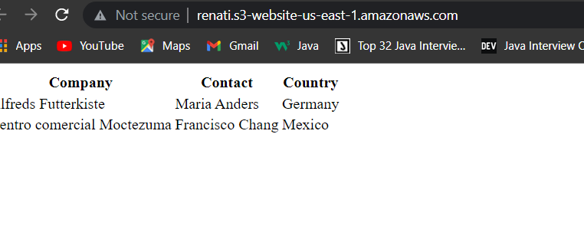

1. **How to generate a bucket policy and give a user specific access on the bucket?**

**1.Create on bucket or use the existing one. There go to permissions.**

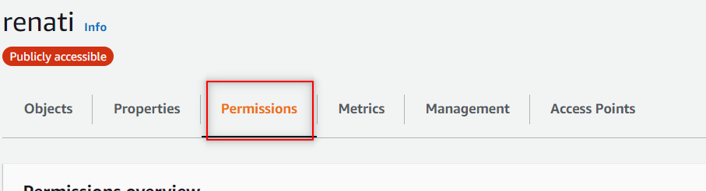

1. **Under permissions u can see the bucket policy there edit that one.**

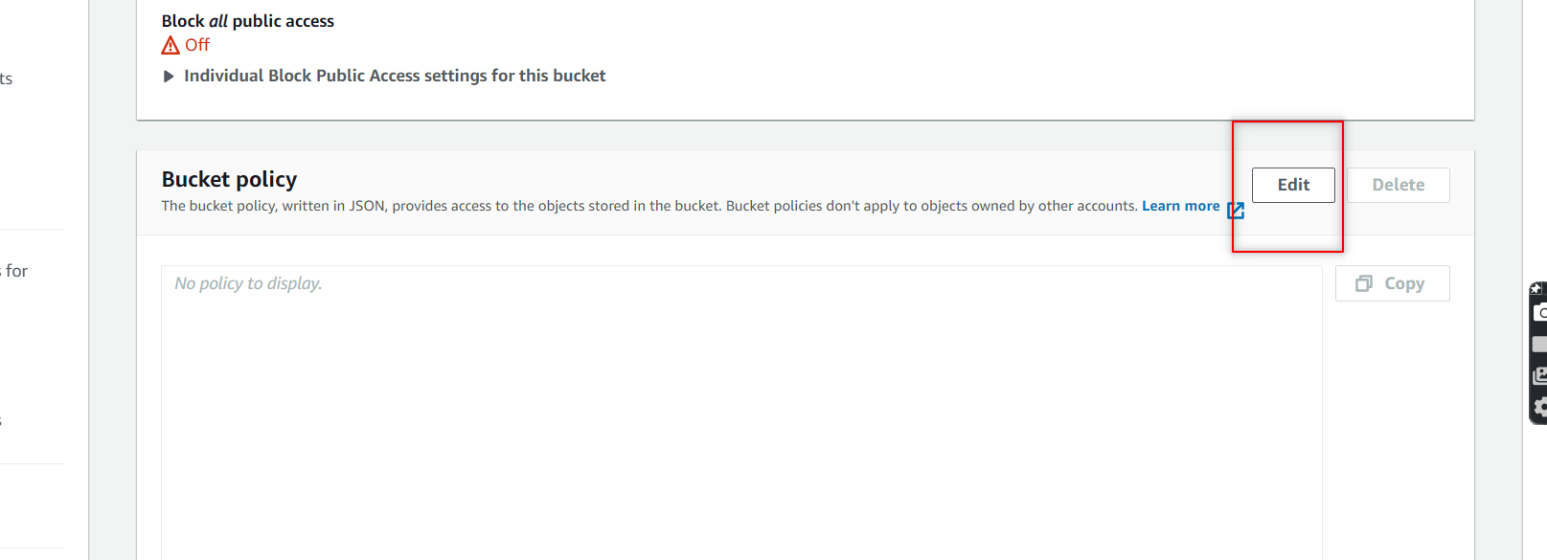

1. **U will navigate to this page and click on policy generator.**

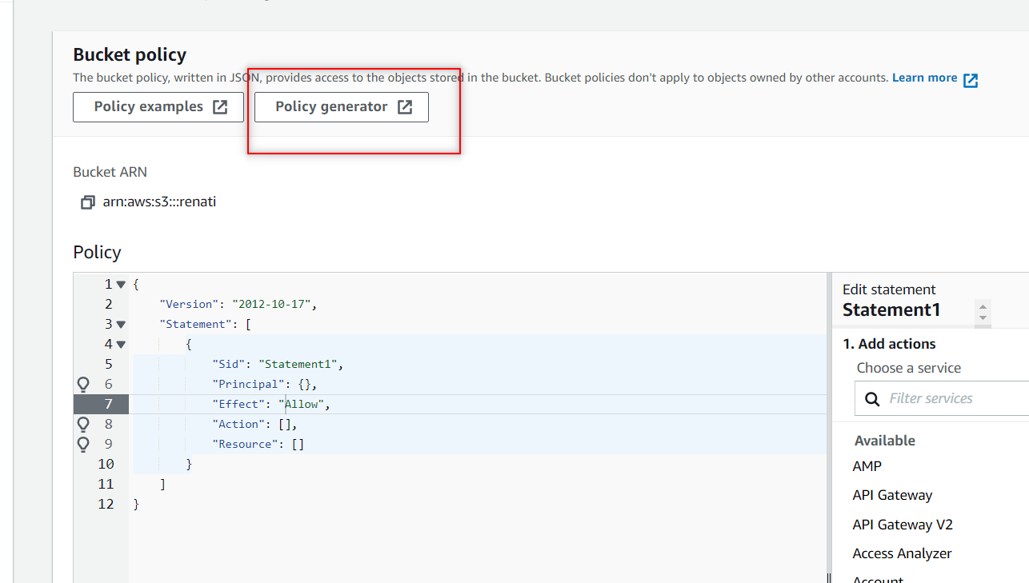

**5.now go to IAM and click on users and see the created users.**

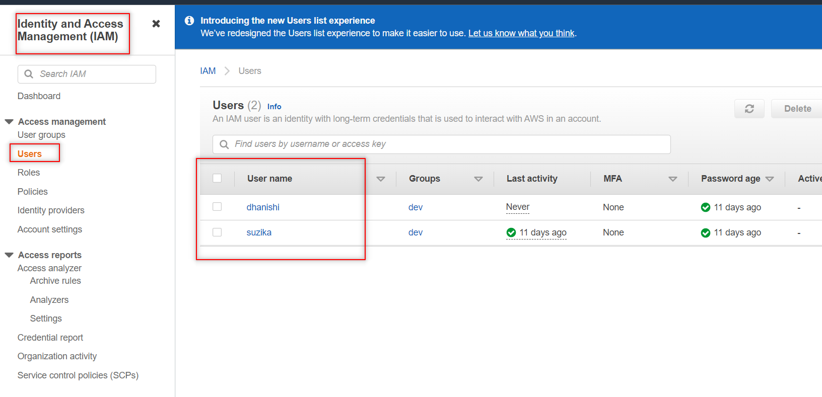

1. **Click on any one user that u created and copy the ARN .**

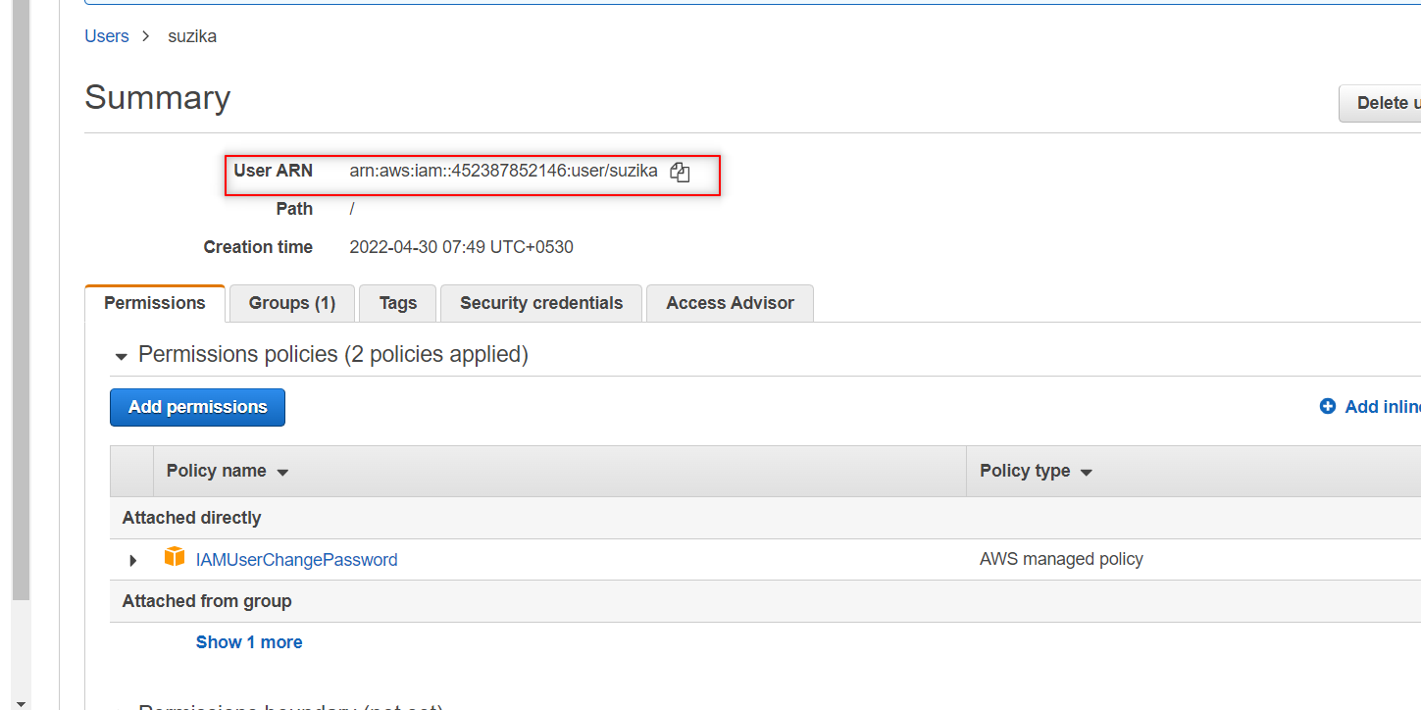

1. **Same copy the bucket ARN which is present under bucket policy.**

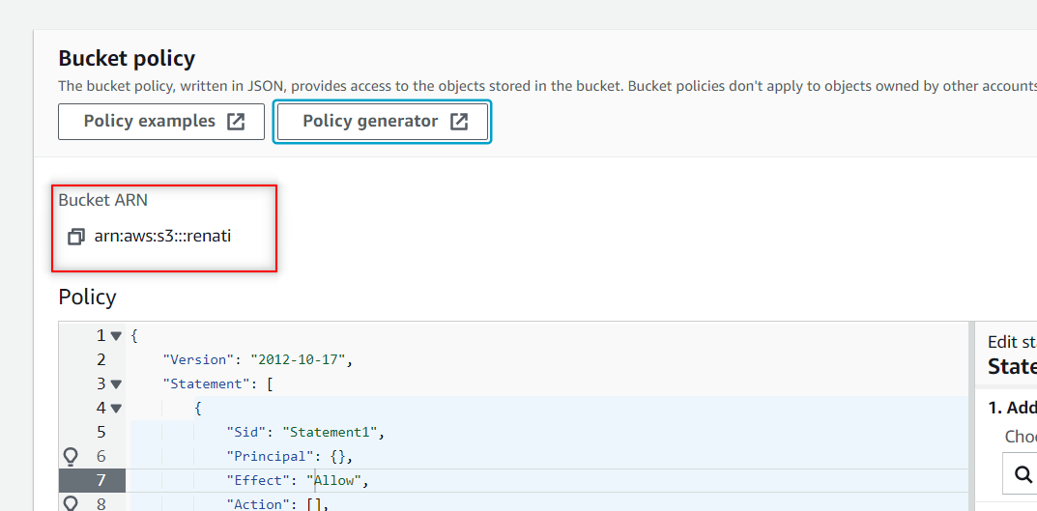

1. **Provide all required fields that mentioned below.and click on add statement and generate policy.**

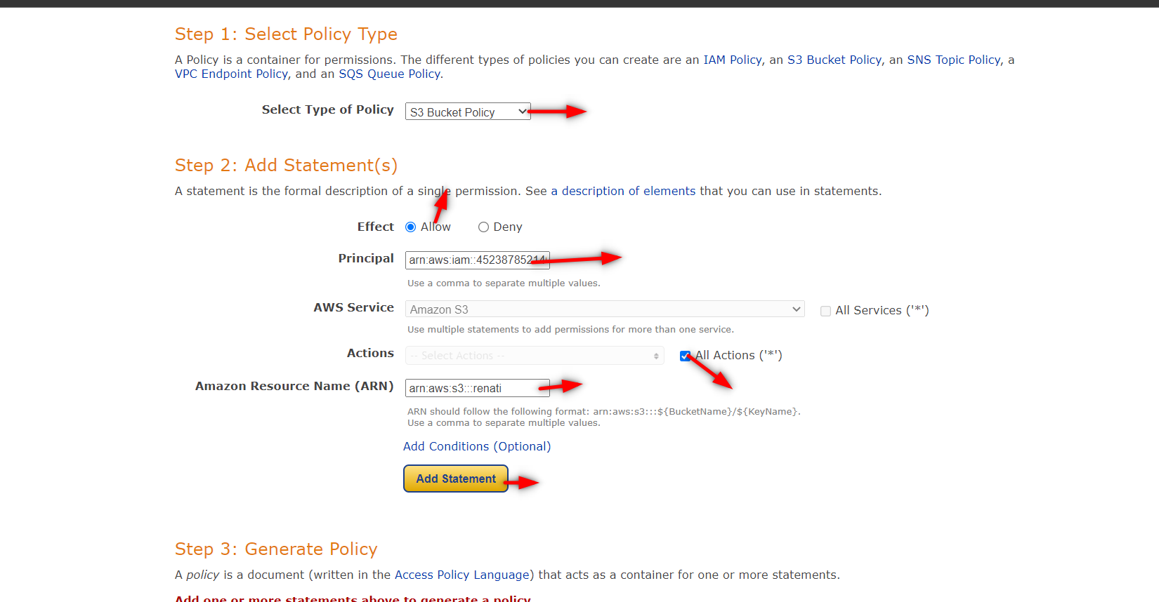

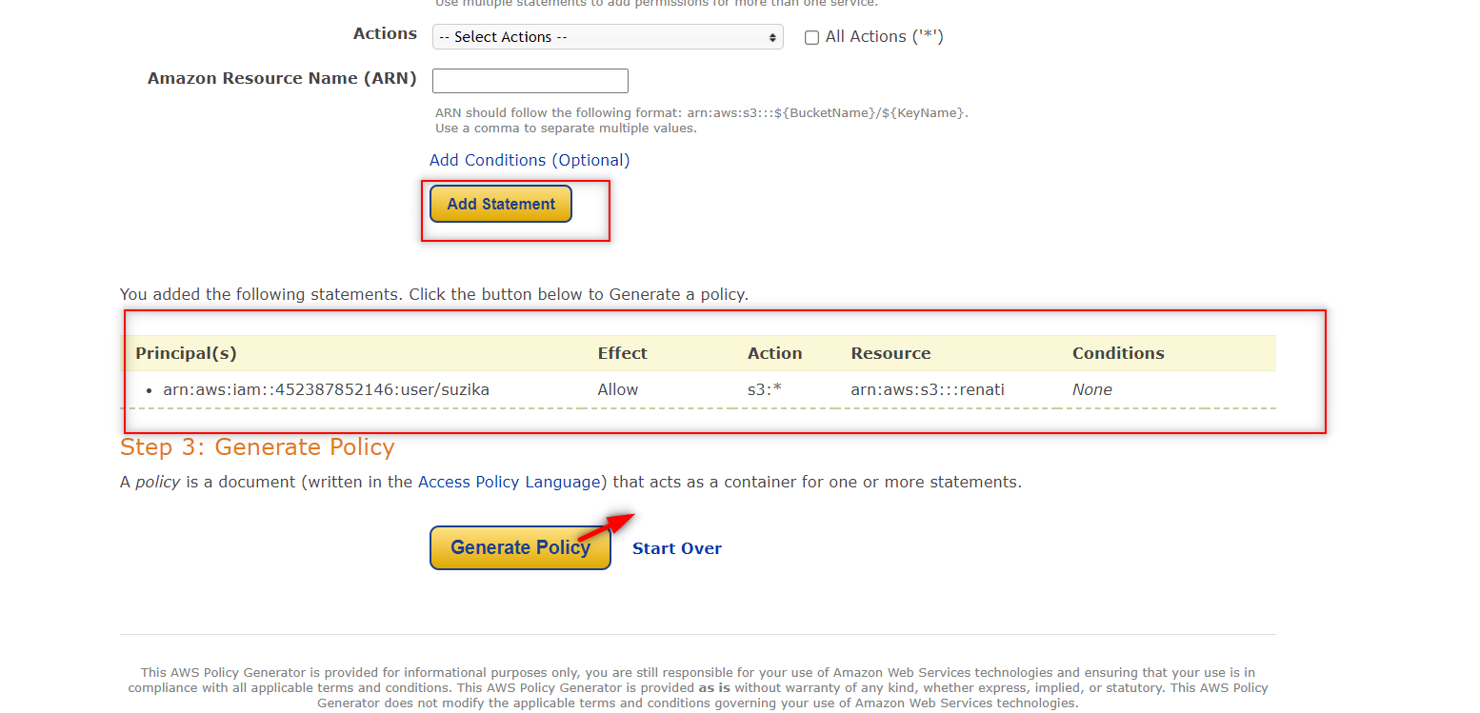

**8.Copy the JSON document.**

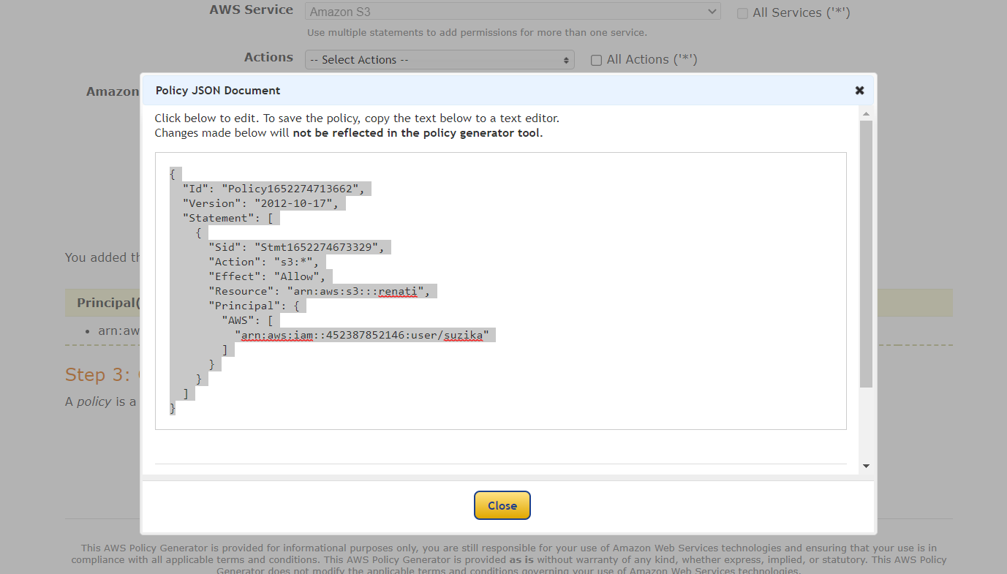

**9.Paste the JSON document under bucket policy. So like this the user can get the access to the bucket through policy.**

